Logging into your Skills & Learning Microsoft 365 account from a personal device

Open a new page in your internet browser
Go to www.office.com
You should see the page below. You have an account - click on ‘Sign in’ and use the details which have been sent to you. Please check you spam/junk folder if you cannot see the email.
Your username/email address will end @salbcp.com
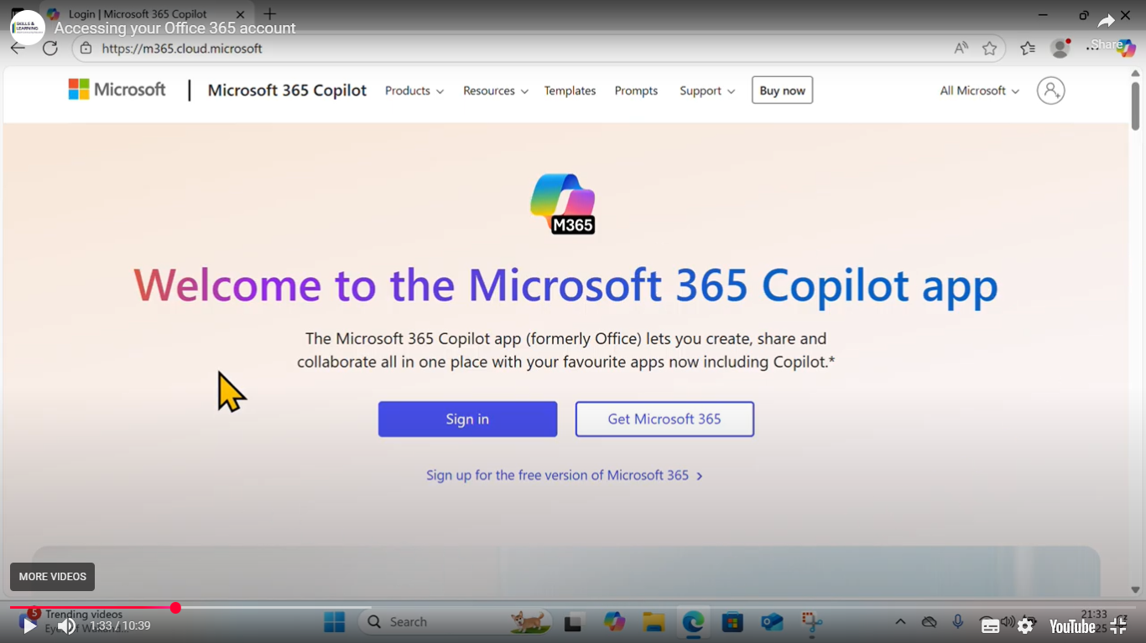
You may be asked to change your password

If you or anyone else uses Microsoft 365 or Teams on the device you are using you will need to use a different browser or sign in using an inprivate or incognito window,
If you are using the Teams app you will need to sign out of the original account and add your salbcp details as another account.
You can get further information by watching this video

https://www.skillsandlearningace.com/learning-with-us/digitalsupport/
If you need further help email support@salbcp.com or ds@salbcp.com
Once signed in you will see various start up screens giving information, you can click through to follow these or close them.
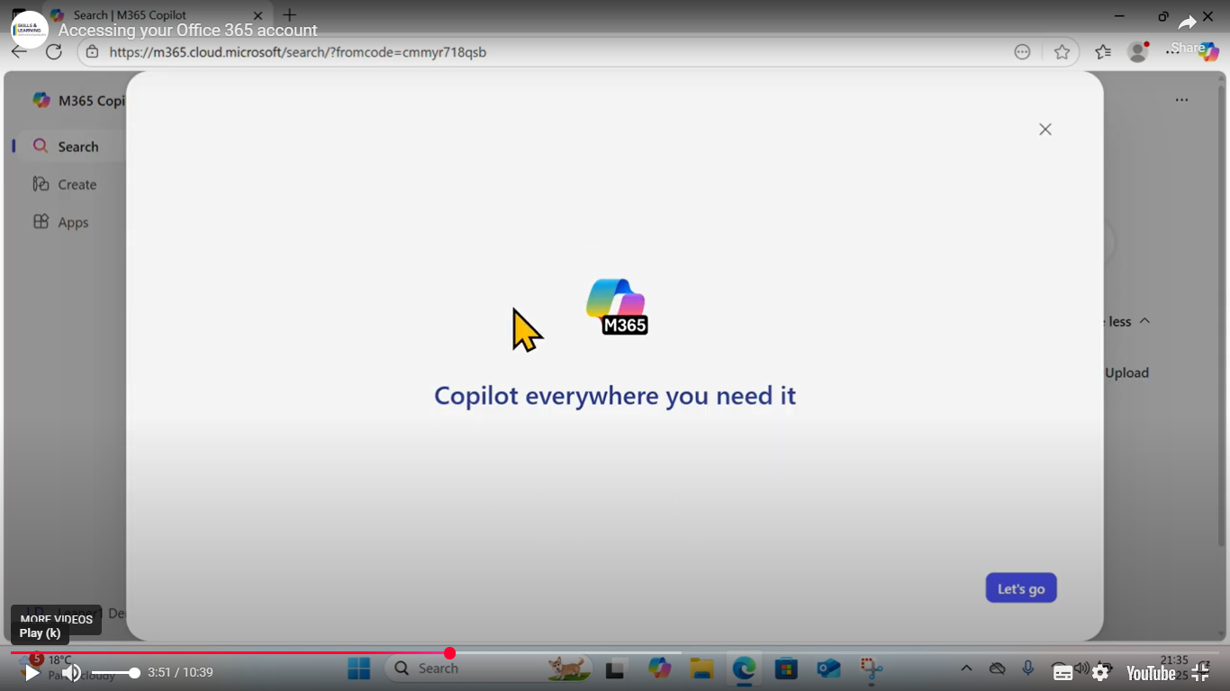

Next you need to click on Apps from the left hand menu
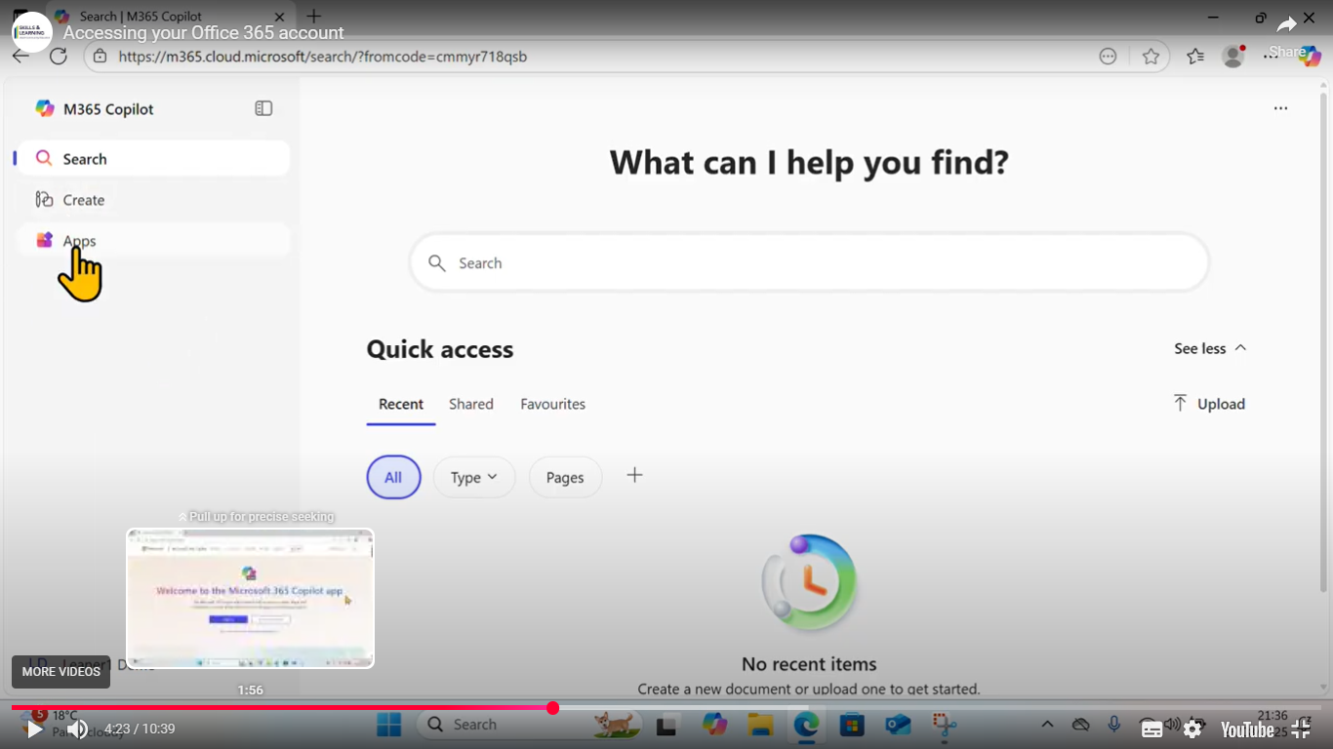

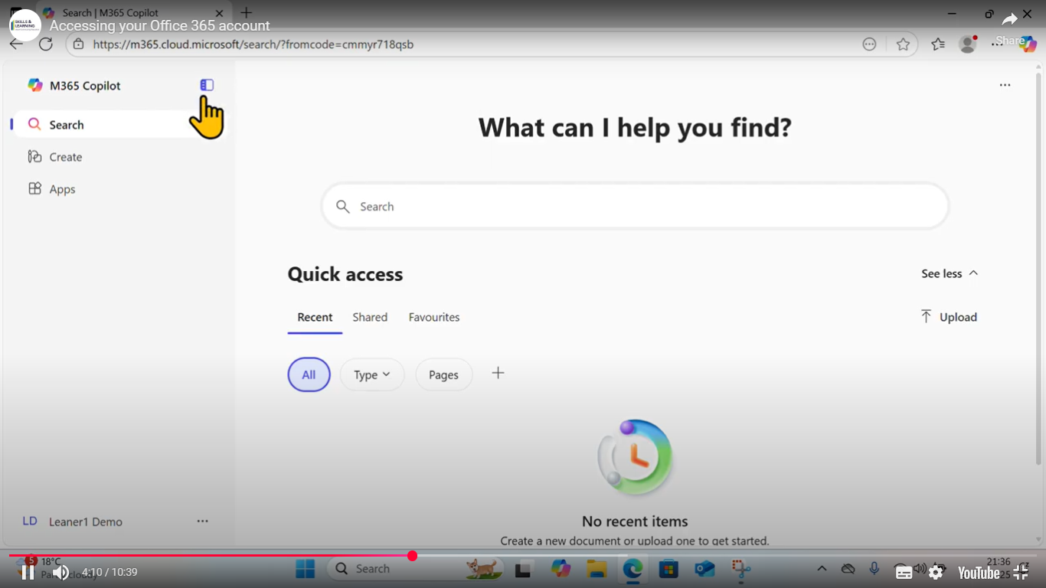
If this is not visible click on the navigation pane as shown here

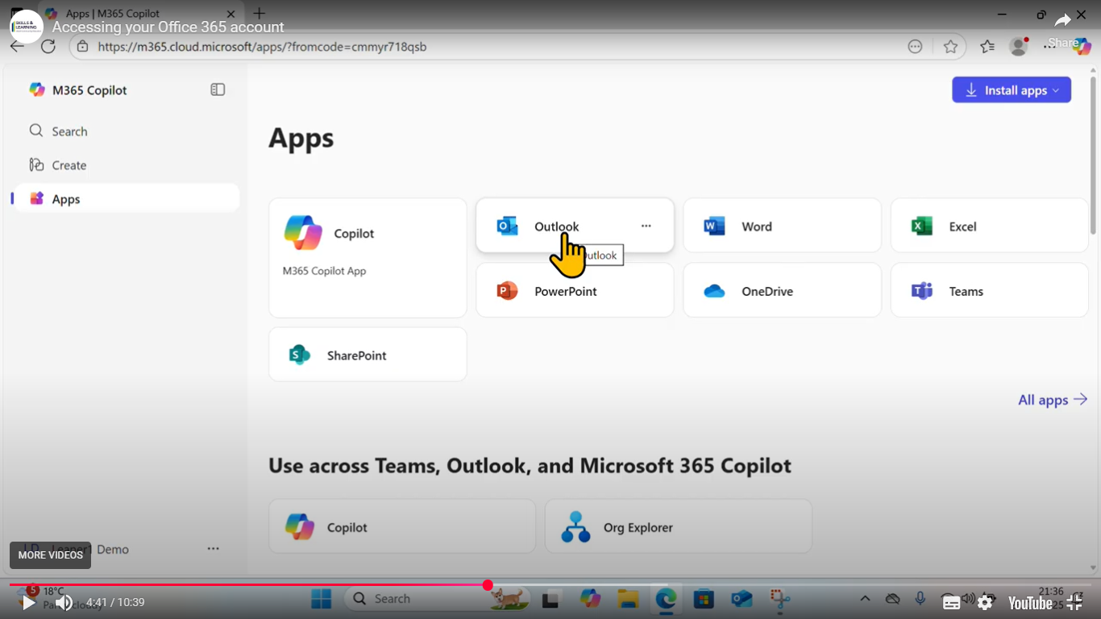
To access your salbcp email click on the Outlook icon

To access your class Team click on Teams

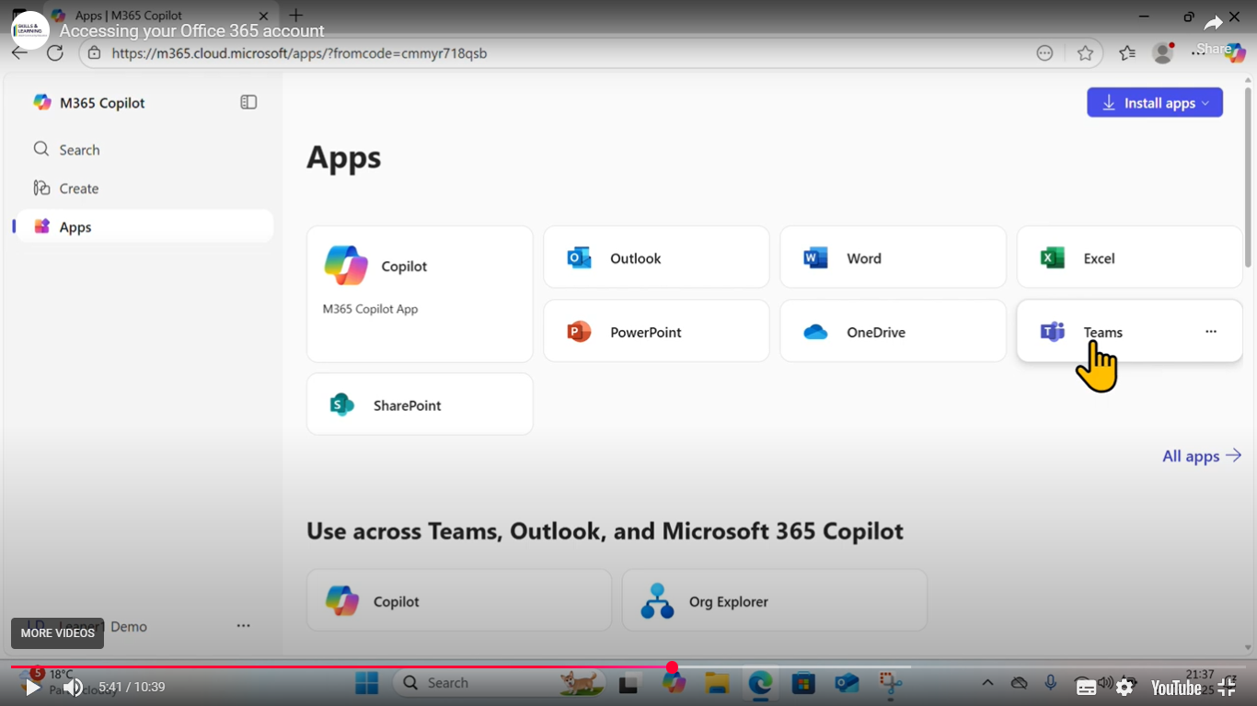

Then click again on Teams from the left hand menu to see which Teams you are a member of.
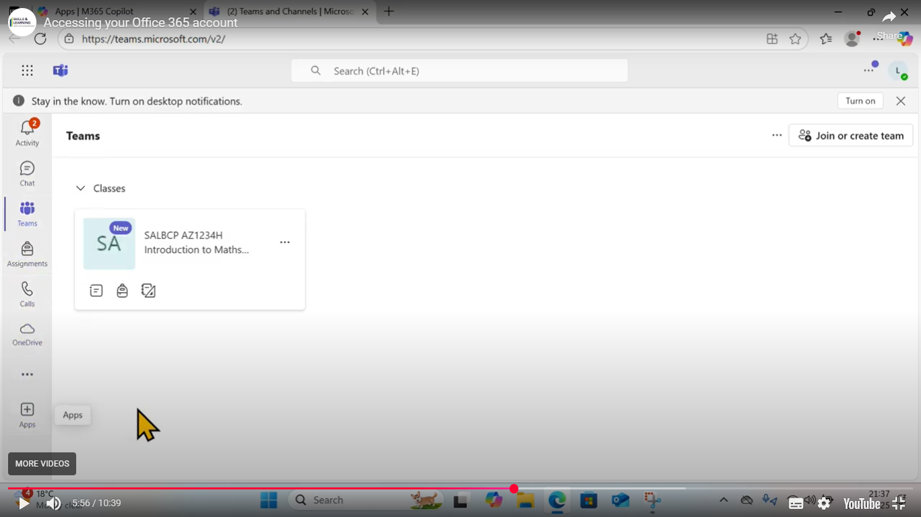

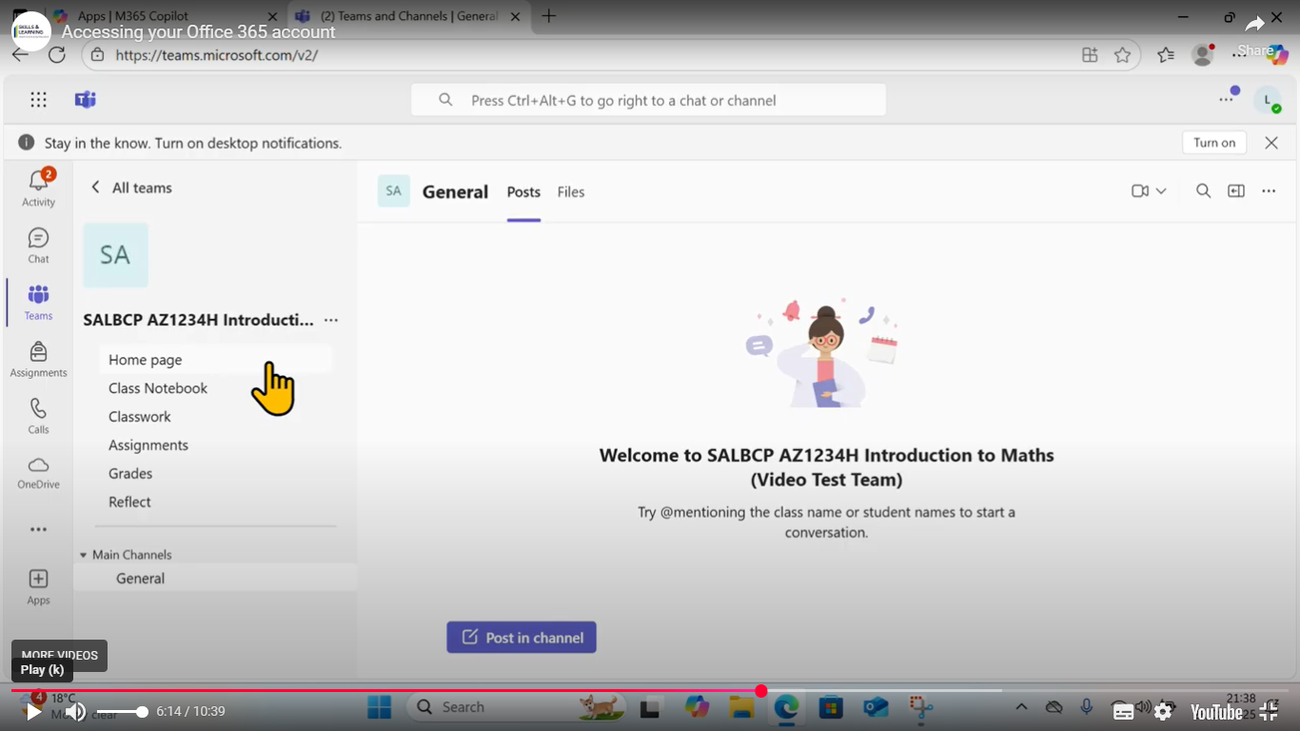
Click on the Team tile to access resources, classwork, assignments etc

To join your Online class meeting click on Calendar in the left hand menu.
If this is not showing click on the 3 dots … and you should then be able to access it
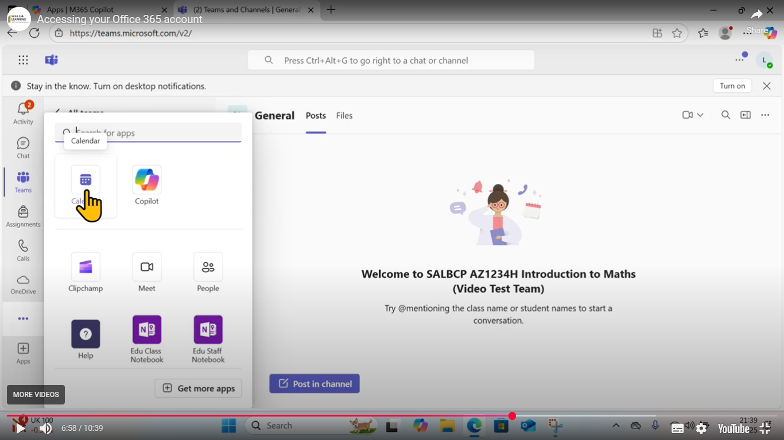

Go to the date and time of the meeting and click ‘Join’
You will see a preview screen and need to click ‘Join’ again.
If asked you need to allow Teams to access your camera and microphone so you can be seen and heard.
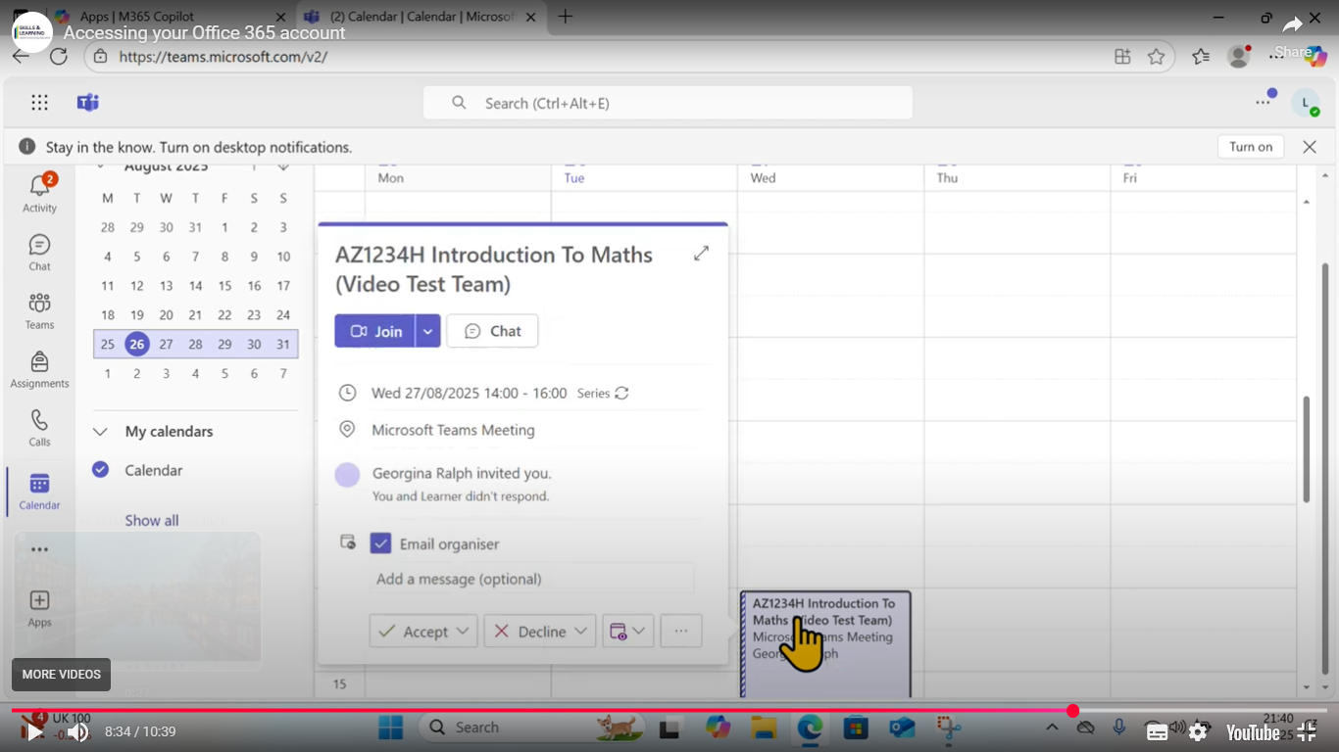

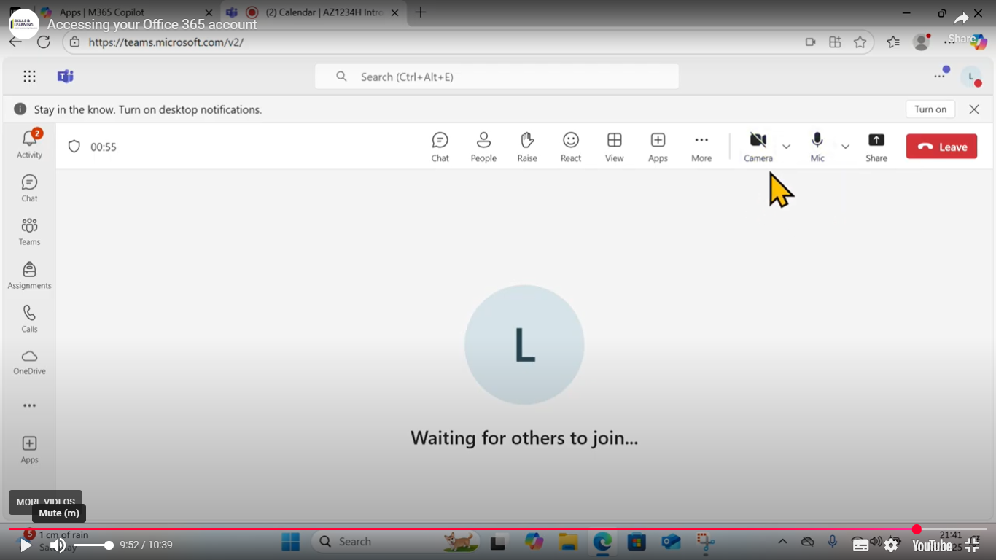
You can turn your camera off and mute your microphone using the icons shown below

